**System Requirement Specifications**

**Uberization of Trucks**

|  |  |
| --- | --- |
| Document version | 3.0 |

Revision History

|  |  |  |  |  |  |
| --- | --- | --- | --- | --- | --- |
| Version | Date | Author | Reviewer | Section | Significant Changes |
| 1.0 | 5/07/2019 | Team 1 | Anand Tyagi, Akhilesh Kumar | Purpose, Scope, Overall System Description, Functional Requirement Specification, Non - Functional Requirement |  |
| 2.0 | 7/07/2019 | Team 1 | Anand Tyagi, Akhilesh Kumar | Functional Requirement Specification |  |
| 3.0 | 10/07/2019 | Team 1 |  |  |  |
|  |  |  |  |  |  |
|  |  |  |  |  |  |
|  |  |  |  |  |  |
|  |  |  |  |  |  |
|  |  |  |  |  |  |
|  |  |  |  |  |  |

Glossary

|  |  |
| --- | --- |
| Abbreviation | Description |
| UBT | Uberization of Trucks |
|  |  |
|  |  |
|  |  |
|  |  |

**Table of Contents**

**Introduction** **6**

**Purpose** **6**

**Scopes** **6**

In Scope: 6

Out of Scope: 6

**Assumptions and Dependencies** **6**

**Overall System Description** **8**

**System Overview** **8**

**System Process Flows** **8**

**Block Diagram** **9**

**Business Roles/Actors** **9**

**Functional Requirement Specification** **10**

**Screens** **10**

Login screen 10

Overview 10

Screen Layout & Field Description 10

Business Rules 10

Use Case 11

Register screen 11

Overview 11

Screen Layout & Field Description 11

Business Rules 12

Use Case 12

Customer Details 13

Customer Edit Profile 14

Customer New Order 16

Customer Current Bids 18

Service Provider Details 20

Service Provider Edit Profile 21

Open Orders Screen 24

Overview 24

Screen Layout & Field Description 24

Business Rules 25

Use Case 25

Current Bids Screen 26

Overview 26

Screen Layout & Field Description 26

Business Rules 27

Use Case 27

**Non - Functional Requirement Specification** **28**

Security 28

Performance Requirements 28

Usability 28

# 

# **Introduction**

## **Purpose**

The Uberization of Trucks is a project to automate the logistics transferring from one place to another. The main idea is that when the customer places the order, all the service providers should be able to give their respective bids for that order and it is up to the customer to select the better service provider on the basis of the bid.

## **Scopes**

UBT aims at providing best services to its customers with an interface that is easy to understand and user friendly. Some of the components of the projects are mentioned below, along with other features which can be added to the project later on.

### **In Scope:**

* Registration of a new customer/service provider.
* Login of an existing customer/service provider.
* Edit Profile (for both the service provider and customer): - The actors will be able to edit their details.
* Placing of order by customer: - The customer will specify the details related to the order which will include category of the shipment item, source and destination location and date for which transportation is needed.
* Bidding on the orders: - The service providers will get the list of available orders open for bidding and will be able to bid on orders.
* Finalizing of an order: - Finally, the customer will select the service provider and order will be finalized between service provider and customer.
* Current Bids: - Service Provider would be able to view at his bidding history and their results.

### **Out of Scope:**

* Multiple orders by customer at the same time and order history for customers.
* Tracing of the orders.
* Admin panel for the user management and maintenance.
* Reviews/Ratings by customers.
* Payment gateway for online payment.

## **Assumptions and Dependencies**

* + **Assumptions: -**
    - Client/Service provider has an active internet connection or has access to one to view the website.
    - Client/Service provider runs an operating system which supports internet browsing.
    - Service providers will bid the order only if they have trucks to transport that order.
  + **Dependencies: -**
    - There should be both service provider and customer over the same platform for the proper functioning of the system.

# **Overall System Description**

## **System Overview**

Our project is mainly aligned towards Customer and Service Provider.

**Customer:**

* Customers can log into their profile using valid credentials.
* They can edit their profile, open new orders and select a service provider for an open order.

**Service Provider:**

* Service Provider can log into their profile using valid credentials.
* They can edit their profile, view open orders, bid on open orders and view bid results.

## **System Process Flows**

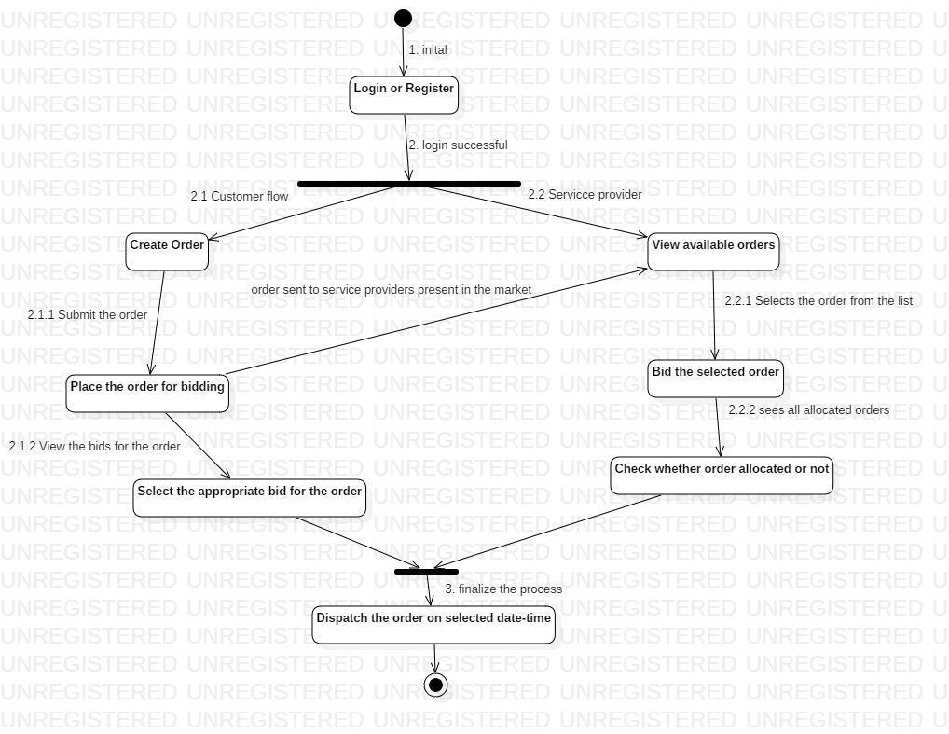

## **Block Diagram**

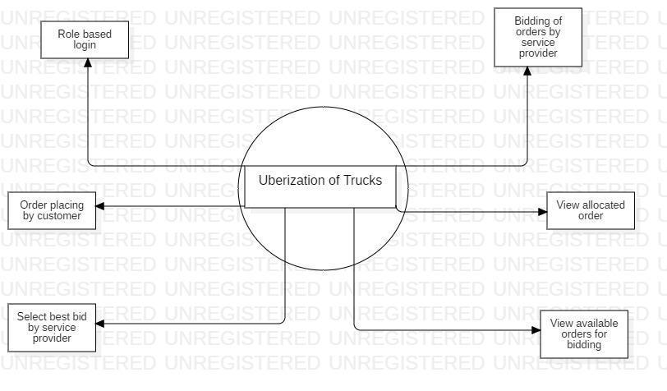

## **Business Roles/Actors**

* + **Customer: -**The main tasks of customer are to create an order which needs to be transported from one place to another at a specific time. When a customer creates an order, it sent to a list of service providers out there in the market which will bid that order and it is upon the customer to select the appropriate service provider.
  + **Service Provider: -** The task of service provider is to view all the new initiated orders out there in the market which they can bid. As per the inventory available the service provider bids for that order in such a manner so that the order is given to him because there are other service providers in that market to give him the competition.

# **Functional Requirement Specification**

## **Screens**

### **Login screen**

###### As per the user email the customer or the service provider can login into the application and view their respective screens.

###### Screen Layout & Field Description

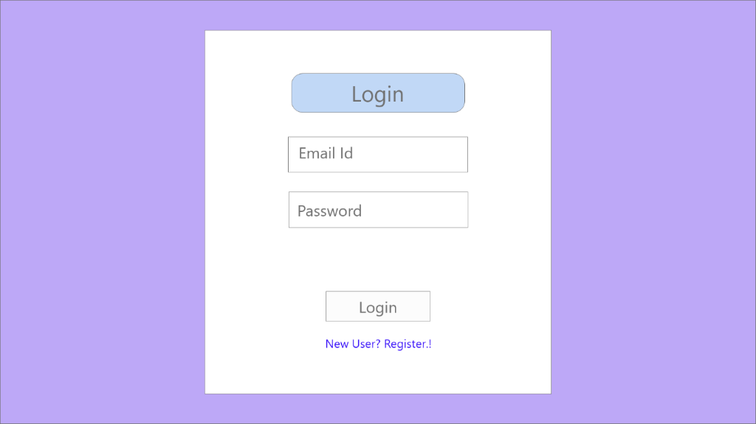

|  |  |  |  |  |  |  |
| --- | --- | --- | --- | --- | --- | --- |
| S.No | Item Name | Item Description | Field Type | Field  Format | Length | Mandatory |
| 1 | Email-id | Input the email of the customer or service provider | Email-text | Text | Varchar(30) | Yes |
| 2 | Password | Individual’s password to be entered over here | Password | Hidden | Varchar(30) | Yes |

###### Business Rules

|  |  |
| --- | --- |
| Business Rule ID | Business Rule |
| 31131 | Email must be valid. |
| 31132 | Password must be at least of 8 characters and must contain at least 1 special character, 1 upper case character, 1 lower case character and 1 numeric character |

###### Use Case

|  |  |
| --- | --- |
| Use Case ID: | 31141 |
| Use Case Description | Login Page |
| Preconditions: | Customer/Service provider must have their own email and password |
| Normal Flow: | * Service provider/customer inputs details for login * Click on the login button and enters his profile page |
| Alternative Flows: | In case of wrong password, an email will be sent to the user’s registered profile with a password reset request. |
| Exceptions: | Wrong password/ ID entered by the customer/service provider. |

### **Register screen**

###### As per the user email the customer or the service provider can login into the application and view their respective screens.

###### Screen Layout & Field Description

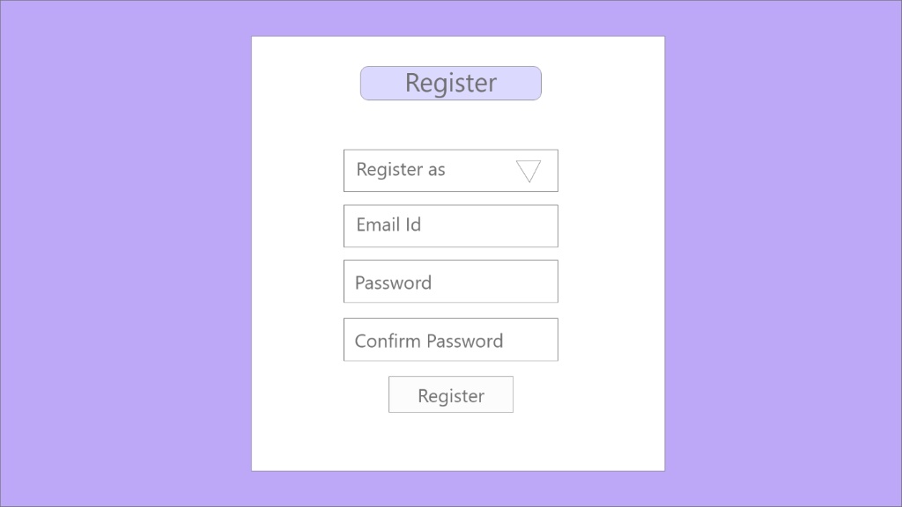

|  |  |  |  |  |  |  |
| --- | --- | --- | --- | --- | --- | --- |
| S.No | Item Name | Item Description | Field Type | Field  Format | Length | Mandatory |
| 1 | Email-id | Input the email of the customer or service provider | Email-text | Text | Varchar(30) | Yes |
| 2 | Register As | Will provide to choose the actor | Dropdown (Customer, Service Provider) | Text | Varchar(30) | yes |
| 3 | Password | Individual’s password to be entered over here | Password | Hidden | Varchar(30) | Yes |
| 4 | Confirm Password | Individual’s password to be entered over here | Password | Hidden | Varchar(30) | Yes |
| 5. | Register | Submit the details on submit click | Submit | Button | Nil | Nil |

###### Business Rules

|  |  |
| --- | --- |
| Business Rule ID | Business Rule |
| 31231 | Email must be valid. |
| 31232 | Password must be at least of 8 characters and must contain at least 1 special character, 1 upper case character, 1 lower case character and 1 numeric character |

###### Use Case

|  |  |
| --- | --- |
| Use Case ID: | 31241 |
| Use Case Description | Register Page |
| Preconditions: | Customer/Service provider must have their own email and password. |
| Normal Flow: | * Service provider/customer email and set his own password for the first time. * Click on confirm password button to finally set his password. * Click on the register button and enters the page where he will enter his/her details for the first time. |
| Alternative Flows: | None |
| Exceptions: | * Wrong password/ ID entered by the customer/service provider. * Password set by the actor is not according to the business rule. |

### **Customer Details**

* + - 1. Customer will enter the details about profile, i.e. Organization Name, Owner’s Name, Business Address and Contact Number. This is done first time a user login.
      2. Screen Layout & Field Description

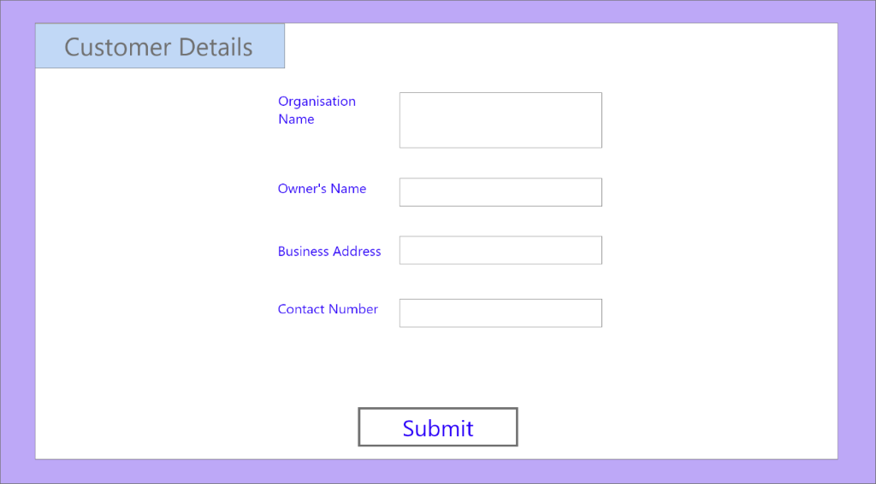

|  |  |  |  |  |  |  |
| --- | --- | --- | --- | --- | --- | --- |
| S.No | Item Name | Item Description | Field Type | Field  Format | Length | Mandatory |
| 1. | Organization Name | Input the organization of the customer | Text | Text | Varchar(50) | Yes |
| 2. | Owner’s Name | Will enter their name | Text | Text | Varchar(30) | Yes |
| 3. | Business Address | Will enter the location address of their organization | Text | Text | Varchar(400) | Yes |
| 4. | Contact Number | Will provide his contact number | Numerical | Integer | Varchar(10) | Yes |
| 5. | Submit | Submit the details on submit click | Submit | Button | Nil | Nil |

* + - 1. Business Rules

|  |  |
| --- | --- |
| Business Rule ID | Business Rule |
| 31331 | Owner’s Name must contain a surname. |
| 31332 | Contact Number must not be more than 10 digits. |

* + - 1. Use Case

|  |  |
| --- | --- |
| Use Case ID: | 31341 |
| Use Case Description | Customer Details (First-Time Registration) Page. |
| Preconditions: | Customer must have their organization (i.e. this software will service commercial use where the customer will make an order for his organization). |
| Normal Flow: | * Customer provide their own details and successfully registers himself. * Click Submit. Profile is updated. Profile Page is opened. |
| Alternative Flows: | None |
| Exceptions: | Any field left empty. |

### **Customer Edit Profile**

* + - 1. Customer will enter the details he wants to change about profile, i.e. Business Address and Contact Number.
      2. Screen Layout & Field Description

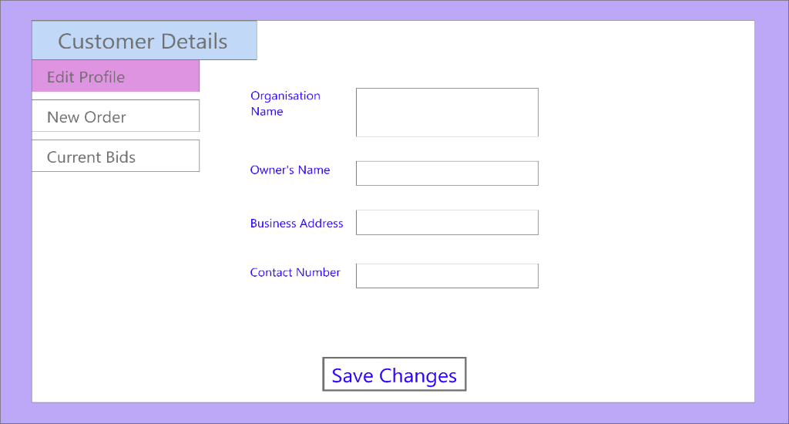

|  |  |  |  |  |  |  |
| --- | --- | --- | --- | --- | --- | --- |
| S.No | Item Name | Item Description | Field Type | Field  Format | Length | Mandatory |
| 1. | Organization Name | organization of the customer will be displayed | Text | Text | Varchar(50) | Yes |
| 2. | Owner’s Name | Name of customer will be displayed | Text | Text | Varchar(30) | Yes |
| 3. | Business Address | Will enter the location address of their organization | Text | Text | Varchar(400) | Yes |
| 4. | Contact Number | Will provide his contact number | Numerical | Integer | Varchar(10) | Yes |
| 5. | Save Changes | The new details on click will be updated in the database | Submit | Button | Nil | Nil |

* + - 1. Business Rules

|  |  |
| --- | --- |
| Business Rule ID | Business Rule |
| 31431 | Owner’s Name must contain a surname. |
| 31432 | Contact Number must not be more than 10 digits. |

* + - 1. Use Case

|  |  |
| --- | --- |
| Use Case ID: | 31441 |
| Use Case Description | Customer Details (Edit Profile) Page. |
| Preconditions: | Customer has their details already entered which they would edit. |
| Normal Flow: | * Customer edits his own details and successfully updates his details. |
| Alternative Flows: | None |
| Exceptions: | None |

### **Customer New Order**

* + - 1. Customer will enter the details for a new order that they want to open, i.e. Source Location, Destination Location, Start Date & Time, Item Details like Category and Load.
      2. Screen Layout & Field Description

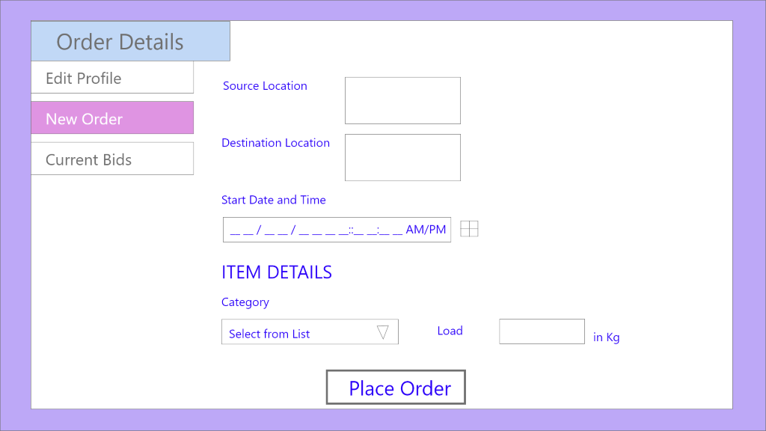

|  |  |  |  |  |  |  |
| --- | --- | --- | --- | --- | --- | --- |
| S.No | Item Name | Item Description | Field Type | Field  Format | Length | Mandatory |
| 1 | Source Location | Input the source location of the customer | Text | Text | Varchar (200) | Yes |
| 2 | Destination Location | Input the destination location of the customer | Text | Text | Varchar (200) | yes |
| 3 | Start Date and Time | Will enter the start date and time of pickup. | Time | Datetime | Not applicable | Yes |
| 4 | Category | Will provide the category of the item to be shipped. | Dropdown (Refrigerated, Non-Refrigerated) | Text | Varchar (51) | Yes |
| 5. | Load | Will provide the load capacity. | Text | Number | Integer | Yes |
| 6. | Place Order | The order will finally be created. | Submit | Button | Nil | Nil |

* + - 1. Business Rules

|  |  |
| --- | --- |
| Business Rule ID | Business Rule |
| 31531 | Start date must be valid i.e. it should not be in the past and not more than 4 weeks in future. |
| 31532 | Load must be greater than zero. |

* + - 1. Use Case

|  |  |
| --- | --- |
| Use Case ID: | 31541 |
| Use Case Description | New Order Page. |
| Preconditions: | Customer should be logged in and profile details must be filled. |
| Normal Flow: | * Customer provides the details of his new order and therefore successfully creates a new order. * Order is moved to a list of open orders available for bidding to service provider. |
| Alternative Flows: | None |
| Exceptions: | None |

### **Customer Current Bids**

* + - 1. Customer will select one of the service providers that have placed their bids on the order shown in the form of a list here along with details of the order.
      2. Screen Layout & Field Description

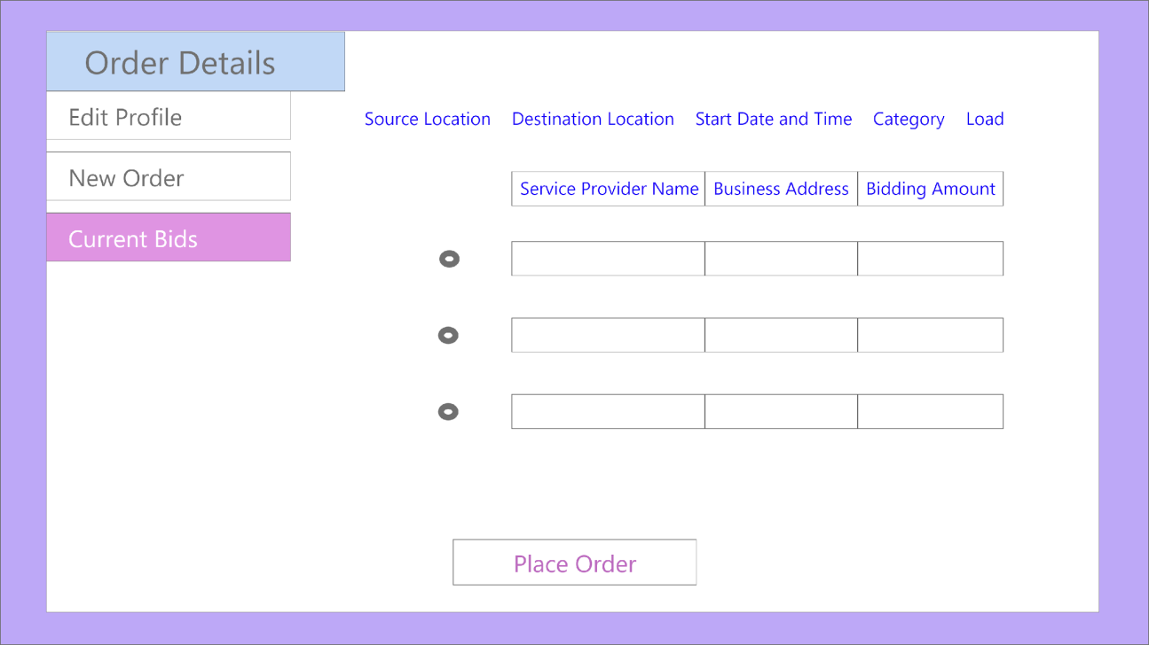

|  |  |  |  |  |  |  |
| --- | --- | --- | --- | --- | --- | --- |
| S.No | Item Name | Item Description | Field Type | Field  Format | Length | Mandatory |
| 1 | Source Location | Already entered | Text | Text | Varchar (200) | Yes |
| 2 | Destination Location | Already entered | Text | Text | Varchar (200) | yes |
| 3 | Start Date and Time | Already entered | Time | Datetime | Not applicable | Yes |
| 4 | Category | Already entered | Text | Text | Varchar (51) | Yes |
| 5. | Load | Already entered | Text | Number | Integer | Yes |
| 6. | Service Provider name | Will display the name of service providers who have placed their bid on the order. | Text | Text | Varchar(50) | Yes |
| 7. | Business Address | Will display the operating region of the service provider. | Text | Text | Varchar(400) | Yes |
| 8. | Bidding Amount | Will display the amount given by service provider | Text | Number | Integer | Yes |
| 9. | Select | Click on the service provider you want to select. | Button | Radio | Not applicable | Yes |
| 10. | Place Order | The order will finally be created. | Submit | Button | Not applicable | No |

* + - 1. Business Rules

|  |  |
| --- | --- |
| Business Rule ID | Business Rule |
| 31631 | One bid must be selected before placing order. |
| 31632 | Bidding amount must be in rupees. |

* + - 1. Use Case

|  |  |
| --- | --- |
| Use Case ID: | 31641 |
| Use Case Description | Current Bids |
| Preconditions: | Customer should be logged in, profile details must be filled and new order has been placed for bidding by the customer. |
| Normal Flow: | * Customer sees the list of all the service providers who have placed their bid on the order created by them. * Customer selects preferred service provider and clicks on place order. |
| Alternative Flows: | None |
| Exceptions: | Place order is clicked without selecting any bid. |

### **Service Provider Details**

* + - 1. Service Provider will enter the details about profile, i.e. Organization Name, Owner’s Name, Business Address and Contact Number. This is done first time a service provider logs in.
      2. Screen Layout & Field Description

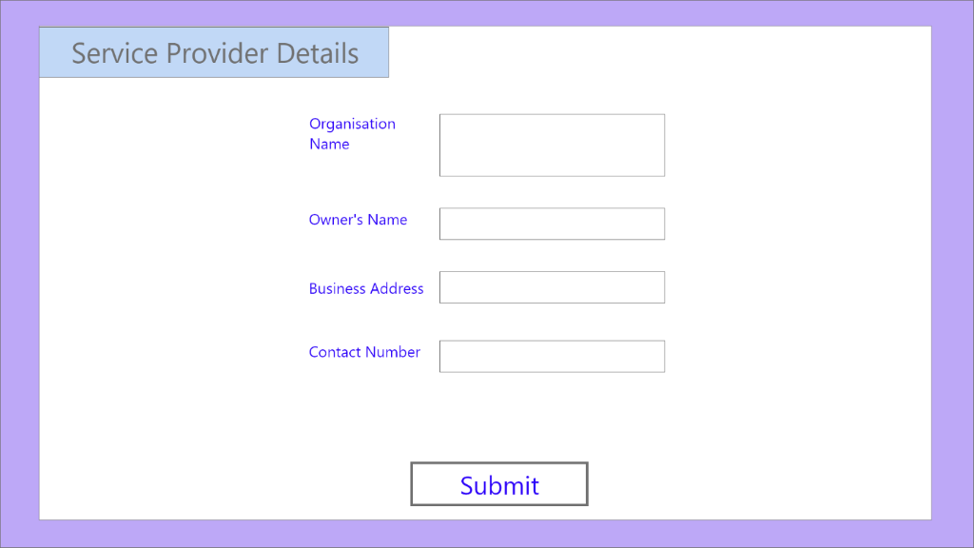

|  |  |  |  |  |  |  |
| --- | --- | --- | --- | --- | --- | --- |
| S.No | Item Name | Item Description | Field Type | Field  Format | Length | Mandatory |
| 1. | Organization Name | Input the organization of the Service Provider | Text | Text | Varchar(50) | Yes |
| 2. | Owner’s Name | Will enter their name | Text | Text | Varchar(30) | Yes |
| 3. | Business Address | Will enter the location address of their organization | Text | Text | Varchar(400) | Yes |
| 4. | Contact Number | Will provide his contact number | Numerical | Integer | Varchar(10) | Yes |
| 5. | Submit | Submit the details on submit click | Submit | Button | Nil | Nil |

* + - 1. Business Rules

|  |  |
| --- | --- |
| Business Rule ID | Business Rule |
| 31731 | Owner’s Name must contain a surname. |
| 31732 | Contact Number must not be more than 10 digits. |

* + - 1. Use Case

|  |  |
| --- | --- |
| Use Case ID: | 31741 |
| Use Case Description | Service Provider Details (First-Time Registration) Page. |
| Preconditions: | Service Provider must have their organization (i.e. this software will service commercial use where the customer will make an order for their organization). |
| Normal Flow: | * Service Provider provide their own details and successfully registers themselves. * Click Submit. Profile is updated. Profile Page is opened. |
| Alternative Flows: | None |
| Exceptions: | One or more details have been left empty and submit button has been  pressed. |

### **Service Provider Edit Profile**

* + - 1. Service Provider will enter the details he wants to change about profile, i.e. Business Address and Contact Number.
      2. Screen Layout & Field Description

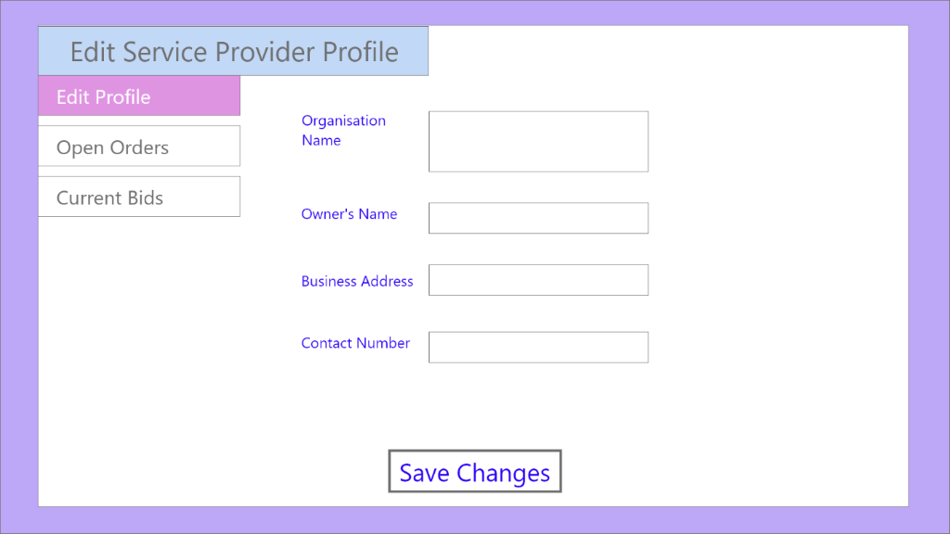

|  |  |  |  |  |  |  |
| --- | --- | --- | --- | --- | --- | --- |
| S.No | Item Name | Item Description | Field Type | Field  Format | Length | Mandatory |
| 1. | Organization Name | organization of the service provider will be displayed | Text | Text | Varchar(50) | Yes |
| 2. | Owner’s Name | Name will be displayed | Text | Text | Varchar(30) | Yes |
| 3. | Business Address | Will enter the location address of their organization | Text | Text | Varchar(400) | Yes |
| 4. | Contact Number | Will provide his contact number | Numerical | Integer | Varchar(10) | Yes |
| 5. | Save Changes | The new details on click will be updated in the database | Submit | Button | Nil | Nil |

* + - 1. Business Rules

|  |  |
| --- | --- |
| Business Rule ID | Business Rule |
| 31831 | Owner’s Name must contain a surname. |
| 31832 | Contact Number must not be more than 10 digits. |

* + - 1. Use Case

|  |  |
| --- | --- |
| Use Case ID: | 31841 |
| Use Case Description | Service Provider Details (Edit Profile) Page. |
| Preconditions: | Service Provider has their details already entered which they would edit. |
| Normal Flow: | * Service provider edits his own details and successfully updates his details. |
| Alternative Flows: | None |
| Exceptions: | None |

### **Open Orders Screen**

###### Service Provider will get a list of all orders open for bidding with their details, I.e. Source location, destination location, Date, Category and Load. They can enter a bidding amount and bid for an order.

###### Screen Layout & Field Description

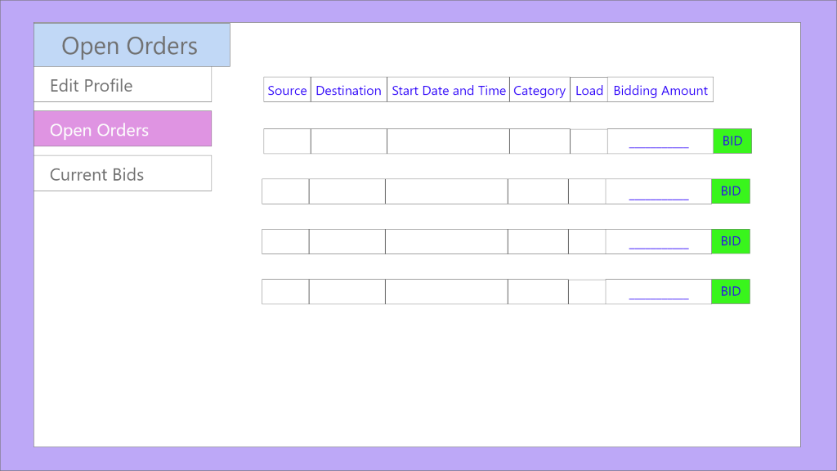

|  |  |  |  |  |  |  |
| --- | --- | --- | --- | --- | --- | --- |
| S.No | Item Name | Item Description | Field Type | Field  Format | Length | Mandatory |
| 1 | Source Location | Already entered | Text | Text | Varchar (200) | Yes |
| 2 | Destination Location | Already entered | Text | Text | Varchar (200) | yes |
| 3 | Start Date and Time | Already entered | Time | Datetime | Not applicable | Yes |
| 4 | Category | Already entered | Text | Text | Varchar (51) | Yes |
| 5. | Load | Already entered | Text | Number | Integer | Yes |
| 6. | Bidding Amount | The service provider will specify the money that will be charged by him for the order | Text | Number | Integer | Yes |
| 7. | Bid | Clicking on this will make the service provider successfully bid on the order | Button | Submit | Not applicable | Yes |

###### Business Rules

|  |  |
| --- | --- |
| Business Rule ID | Business Rule |
| 31931 | Amount must be greater than zero and in rupees. |
| 31932 | Bid can be placed only once for any order. |

###### Use Case

|  |  |
| --- | --- |
| Use Case ID: | 31941 |
| Use Case Description | Open Orders(As visible by service-provider) |
| Preconditions: | Service Provider should be logged in and has filled his profile details. |
| Normal Flow: | * Service provider sees the list of open orders and enters amount for bids. * Click on Bid button to submit the bid for consideration by customer. |
| Alternative Flows: | None |
| Exceptions: | * Service Provider clicks bid button when bid has already have been placed once by them. * Service Provider clicks bid button when amount is not valid (Empty or Less than Equal to Zero). |

### **Current Bids Screen**

###### Service Provider will be provided with a list of his bids along with order details and result,I.e., selected, rejected or undecided.

###### Screen Layout & Field Description

###### 

|  |  |  |  |  |  |  |
| --- | --- | --- | --- | --- | --- | --- |
| S.No | Item Name | Item Description | Field Type | Field  Format | Length | Mandatory |
| 1 | Source Location | Already entered | Text | Text | Varchar (200) | Yes |
| 2 | Destination Location | Already entered | Text | Text | Varchar (200) | yes |
| 3 | Start Date and Time | Already entered | Time | Datetime | Not applicable | Yes |
| 4 | Category | Already entered | Text | Text | Varchar (51) | Yes |
| 5. | Load | Already entered | Text | Number | Integer | Yes |
| 6. | Bidding Amount | Already entered | Text | Number | Integer | Yes |
| 7. | Result | Will get to see whether the bid on a specific order has been accepted or rejected or undecided. | List(Accepted,Rejected,Undecided) | Text | Not Applicable | Yes |

###### Business Rules

|  |  |
| --- | --- |
| Business Rule ID | Business Rule |
| 311031 | Result can only have 3 values – Selected, Rejected or Undecided. |

###### Use Case

|  |  |
| --- | --- |
| Use Case ID: | 311041 |
| Use Case Description | Current Bids(As visible to service-provider) |
| Preconditions: | Service Provider should be logged in and has filled his profile details. |
| Normal Flow: | * Service Provider sees the list of open orders and the result of the bids (accepted or rejected or undecided by the customer) |
| Alternative Flows: | In case of no bids, the page will be empty. |
| Exceptions: | Nil. |

# 

# **Non - Functional Requirement Specification**

## **Security**

∙ Input Filtering

∙ Database Security

∙ Password Encryption

## **Performance Requirements**

∙ Client-Side Validation

∙ Caching

∙ Persistent Connections

## **Usability**

∙ Users should not be required to consult a manual each time. Interface should be easy to use and remember.